Legend

**Matplotlib** is one of the most popular Python packages used for data visualization. It is a cross-platform library for making 2D plots from data in arrays. **Pyplot** is a collection of command style functions that make matplotlib work like MATLAB. Each pyplot function makes some change to a figure: e.g., creates a figure, creates a plotting area in a figure, plots some lines in a plotting area, decorates the plot with labels, etc.

**Matplotlib.pyplot.legend()**

A legend is an area describing the elements of the graph. In the matplotlib library, there’s a function called **legend()** which is used to Place a legend on the axes.

The attribute **Loc** in legend() is used to specify the location of the legend.Default value of loc is loc=”best” (upper left). The strings ‘upper left’, ‘upper right’, ‘lower left’, ‘lower right’ place the legend at the corresponding corner of the axes/figure.

The attribute **bbox_to_anchor=(x, y)** of legend() function is used to specify the coordinates of the legend, and the attribute **ncol** represents the number of columns that the legend has.It’s default value is 1.

*matplotlib.pyplot.legend([“blue”, “green”], bbox_to_anchor=(0.75, 1.15), ncol=2)*

The Following are some more attributes of function legend() :

* **shadow**: [None or bool] Whether to draw a shadow behind the legend.It’s Default value is None.
* **markerscale**: [None or int or float] The relative size of legend markers compared with the originally drawn ones.The Default is None.
* **numpoints**: [None or int] The number of marker points in the legend when creating a legend entry for a Line2D (line).The Default is None.
* **fontsize**: The font size of the legend.If the value is numeric the size will be the absolute font size in points.
* **facecolor**: [None or “inherit” or color] The legend’s background color.
* **edgecolor**: [None or “inherit” or color] The legend’s background patch edge color.

import numpy as np

import matplotlib.pyplot as plt

# X-axis values

x = [1, 2, 3, 4, 5]

# Y-axis values

y = [1, 4, 9, 16, 25]

# Function to plot

plt.plot(x, y)

# Function add a legend

plt.legend(['single element'])

# function to show the plot

plt.show()

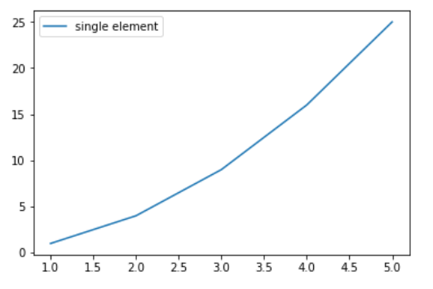

# importing modules

import numpy as np

import matplotlib.pyplot as plt

# Y-axis values

y1 = [2, 3, 4.5]

# Y-axis values

y2 = [1, 1.5, 5]

# Function to plot

plt.plot(y1)

plt.plot(y2)

# Function add a legend

plt.legend(["blue", "green"], loc ="lower right")

# function to show the plot

plt.show()

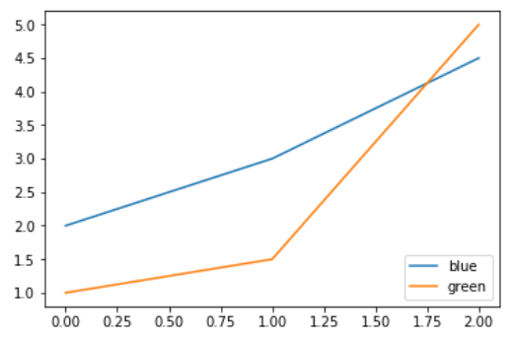

import numpy as np

import matplotlib.pyplot as plt

# X-axis values

x = np.arange(5)

# Y-axis values

y1 = [1, 2, 3, 4, 5]

# Y-axis values

y2 = [1, 4, 9, 16, 25]

# Function to plot

plt.plot(x, y1, label ='Numbers')

plt.plot(x, y2, label ='Square of numbers')

# Function add a legend

plt.legend()

# function to show the plot

plt.show()

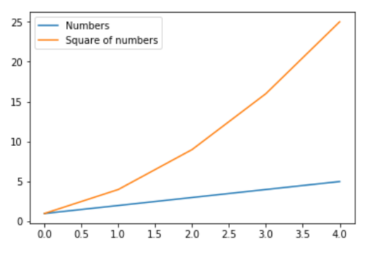

import numpy as np

import matplotlib.pyplot as plt

x = np.linspace(0, 10, 1000)

fig, ax = plt.subplots()

ax.plot(x, np.sin(x), '--b', label ='Sine')

ax.plot(x, np.cos(x), c ='r', label ='Cosine')

ax.axis('equal')

leg = ax.legend(loc ="lower left");

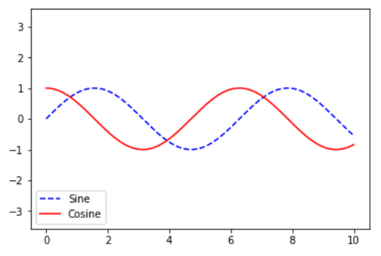# importing modules

import numpy as np

import matplotlib.pyplot as plt

# X-axis values

x = [0, 1, 2, 3, 4, 5, 6, 7, 8]

# Y-axis values

y1 = [0, 3, 6, 9, 12, 15, 18, 21, 24]

# Y-axis values

y2 = [0, 1, 2, 3, 4, 5, 6, 7, 8]

# Function to plot

plt.plot(y1, label ="y = x")

plt.plot(y2, label ="y = 3x")

# Function add a legend

plt.legend(bbox_to_anchor =(0.75, 1.15), ncol = 2)

# function to show the plot

plt.show()

